INSTITUTE OF COMPUTER TECHNOLOGY
B-TECH COMPUTER SCIENCE ENGINEERING 2025-26
SUBJECT: IDENTITY ACCESS MANAGEMENT
NAME: Rahul Prajapati
ENRLL. NO: 23162171020
BRANCH: CYBER SECURITY
BATCH: 52
Lab 1: Installing Docker and Keycloak
STEP_1:
- INSTALL DOCKER DESKTOP
STEP_2
- SIGNING UP DOCKER ACCOUNT
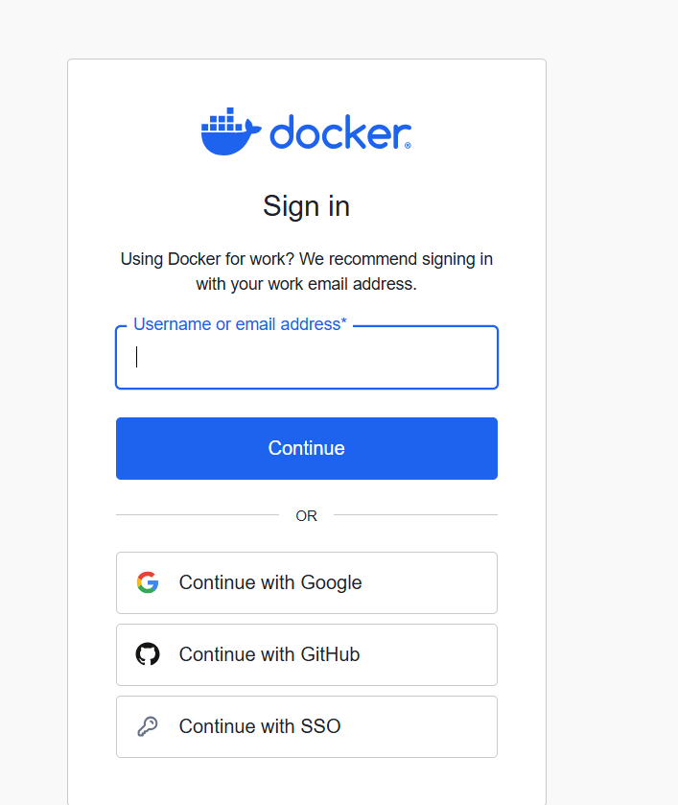

STEP_3:
- PULLING KEYCLOAK IMAGE FROM DOCKER
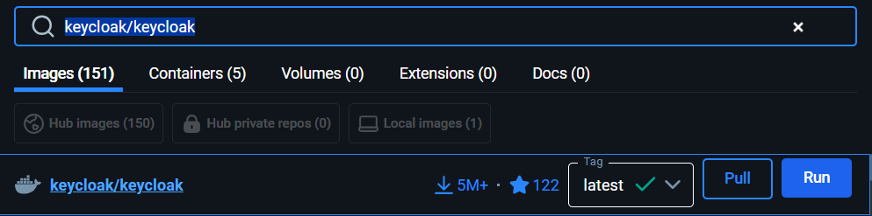

STEP_4:
- RUN KEYCLOAK
  - >>>docker pull keycloak/keycloak
  - >>>docker run -p 8080:8080 -e KEYCLOAK_ADMIN=admin -e KEYCLOAK_ADMIN_PASSWORD=admin keycloak/keycloak start-dev
  - NOTE:RUN ON CMD
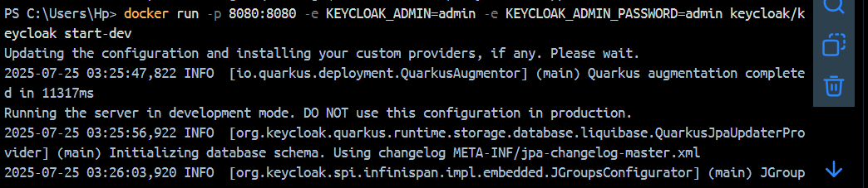
STEP_5:
- Run http://localhost:8080 on browser
- Login by username=admin & password=admin
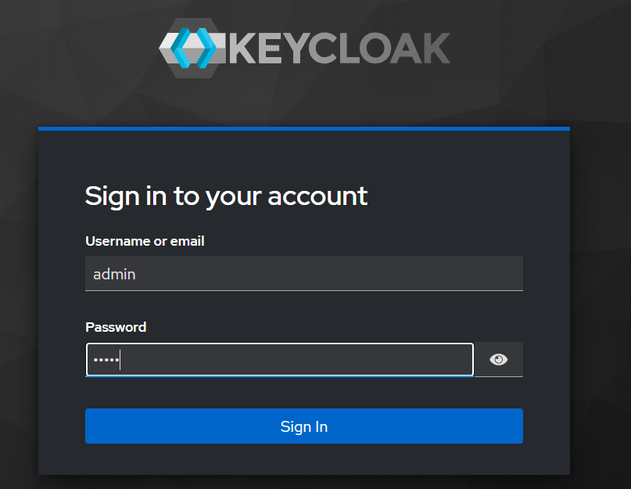
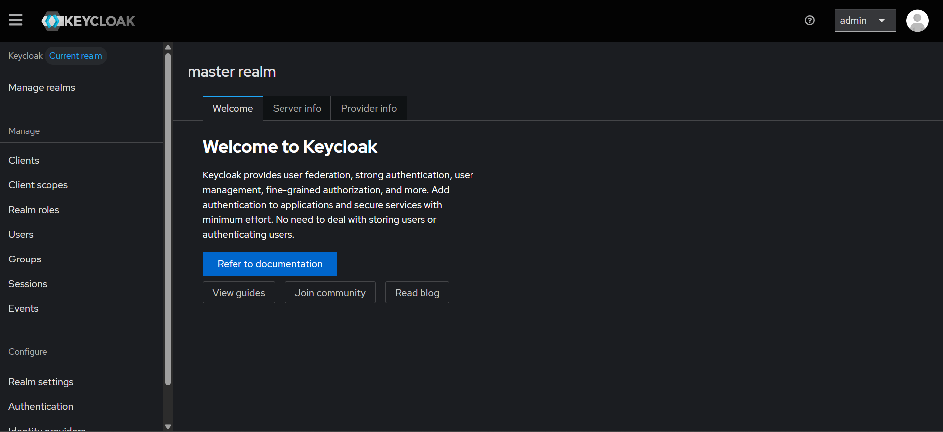

What is the difference between docker and Virtualization? Why do we use docker?
No. | Feature | Docker (Containerization) | Virtualization (VMs)
1 | OS requirement | Shares host OS kernel | Each VM has its own full OS
2 | Boot-up speed | Starts in seconds | Takes minutes to boot
3 | Resource usage | Lightweight, uses less RAM and CPU | Heavy, consumes more RAM and CPU
4 | Performance | Near-native performance | Slightly slower due to full OS layer
5 | Size | Small container image size (MBs) | Large VM images (GBs)
6 | Isolation level | Process-level isolation (less secure than VMs) | Full OS-level isolation (more secure)
7 | Portability | Highly portable across systems | Less portable (OS dependencies)
8 | Use case | Ideal for microservices, CI/CD, cloud apps | Ideal for running different OSes, full environments
9 | Dependency handling | Bundles all app dependencies inside the container | Needs separate setup for each VM
10 | Management | Easier to manage with tools like Docker Compose, Kubernetes | More complex to manage multiple VMs
11 | Storage | Containers share layers, saving space | Each VM has its own full disk image
12 | Security | Good, but shares kernel – some risks | Better isolation due to separate OS

- Docker is used to package applications with all their dependencies into lightweight, portable containers that run consistently across different environments. It makes development, testing, and deployment faster, more reliable, and easier to scale.

